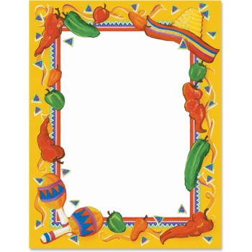

TOUR DE COMIDA HISPANA

As a culminating assessment of our food unit, we will be having a Hispanic Food Tasting Tour in class on Thursday, April 21 and Friday, April 22. Your child will be asked to bring in an authentic Spanish food or drink item based on his/ her menu from class. Please complete the bottom form of this slip so your child can participate in this fun and meaningful activity. Please let us know if for any reason your child cannot participate in the activity.

If you have any questions or concerns, please feel free to email us.

¡Gracias!
Señora Jimenez
vjimenez@spfk12.org

Señora Patunas
mpatunas@spfk12.org

******************************************************************

My child ___________________________ has my permission to participate in the international food tasting in Spanish class.

My child ____________________________ does not have permission to participate in the international food tasting in Spanish class.

Any allergies? _________________________________________________

Signature: ____________________________________________________

