Nombre______________________________ Fecha______________________________________

¿Qué le gusta hacer?

Directions: write complete sentences that represent each of the pictures.
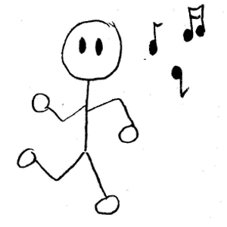

1. Diego/no
____________________________________________________________________________________
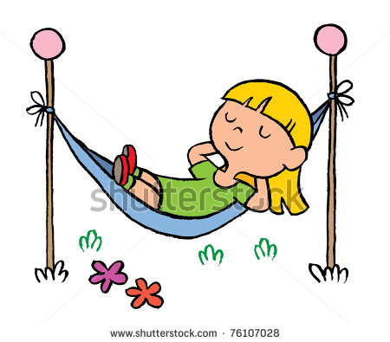
2. Dora/
____________________________________________________________________________________

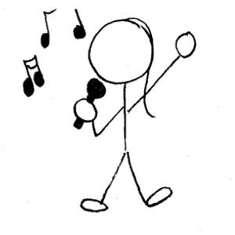

3. Rosa/
____________________________________________________________________________________

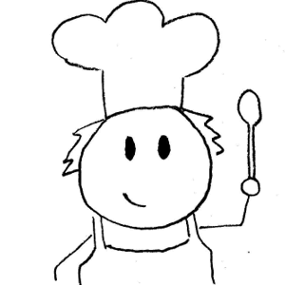
4. Marcelo/no

____________________________________________________________________________________

5. Johanna/

____________________________________________________________________________________

6. Andres/
____________________________________________________________________________________

7. A mi/

___________________________________________________________________________________

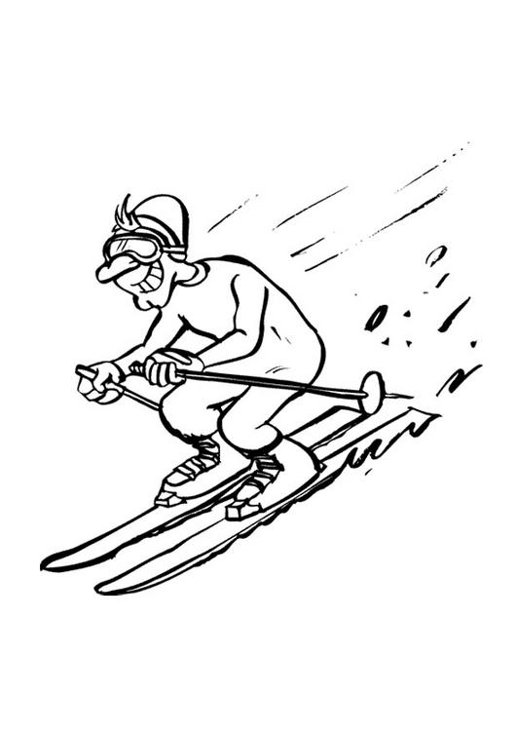
8. Raúl/no

____________________________________________________________________________________

