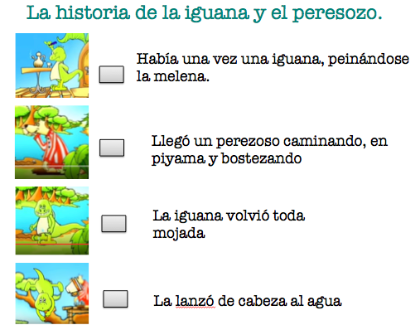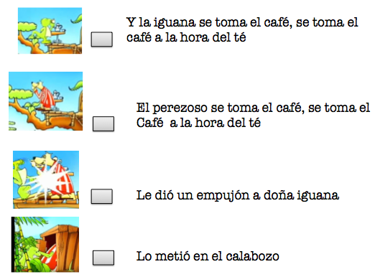

Nombre: _____________________________________

Activity: Write number 1 to 8 in the boxes and put the story in order.