**Nombre: _____________________________ Fecha: _____________________________________**

**HACER AHORA**

**-Escribe donde están los muebles *(Write where the furniture is located)***

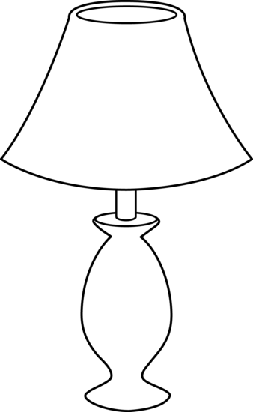

1. La _________________está ___________________ de la ____________________.

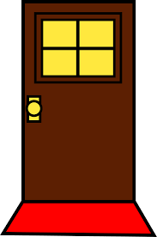

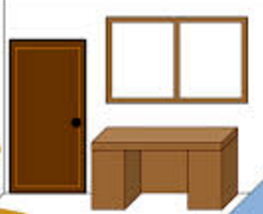

1. La __________________ está ___________________ de la ___________________.

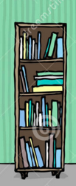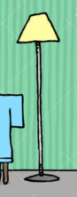

1. La ________________ está _____________________ de la ___________________

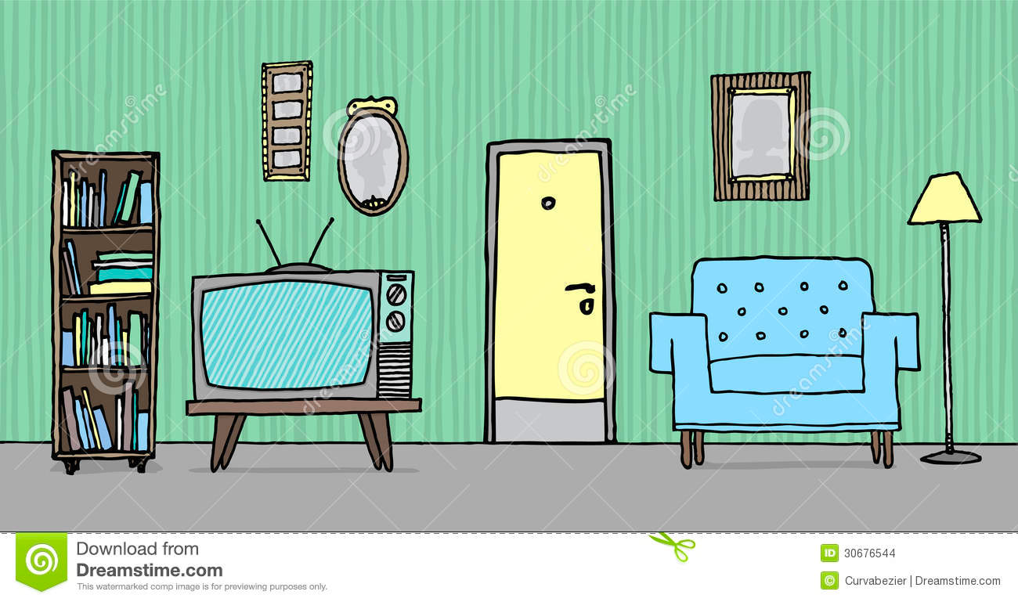

pero está ____________________ del ____________________________ .

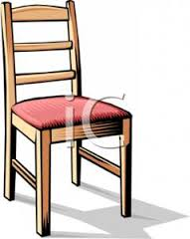

1. La ________________________ está _________________________

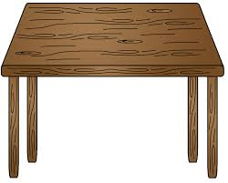

de la ________ _____________________.